common name: cranberry fruitworm

scientific name: *Acrobasis vaccinii* (Riley) (Lepidoptera: Pyralidae)

**Introduction – Distribution – Hosts – Natural Enemies – Economic Importance – Description** **– Life History –Selected References**

**Introduction**

Cranberry fruitworms (*Acrobasis* *vaccinii* (Riley)) (**Figure 1**) are a native lepidopteran moth here in North America. The host range of these insects is limited berry producing plants of the genus *Gaylussacia* and the genus *Vaccinium* which includes large fruit cranberry (*Vaccinium macrocarpon* Aiton) and highbush blueberry plants (*Vaccinium* spp. L.) (Averill and Sylvia 1998). Cranberry fruitworms are the primary pest of large fruit cranberries and a significant pest of highbush blueberries (Fitzpatrick 2008). Infestations of these fruit pests in cranberry bogs have been recorded to have destroyed up to 50% of a cranberry crop (Simser 1994).

The life history of cranberry fruitworms is closely synchronized with the fruit hosts on which they depend.

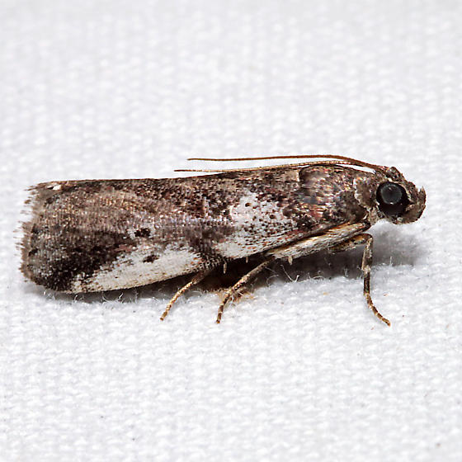

**Figure 1.** Adult cranberry fruitworm, *Acrabasis vaccinii* (lateral view). Photograph by Ken Childs, kjchilds@yahoo.com*.*

**Distribution**

Cranberry fruitworm have been recorded across eastern North America from Florida to nova Scotia and westward to Wisconsin and Texas (Averill and Sylvia 1998, Cee and Liburd 1993, Murray et al. 1996, Neunzig 1972).

**Hosts**

*Acrobasis vaccinii* larvae are herbivorous and feed exclusively inside the developing fruit produced by their host plant. Populations of cranberry fruitworm have been collected from cranberries, blueberries, deerberries, cowberries, huckleberries, dangleberries, apples, and beach plums (Nikhil and Isaacs 2002, Neunzig 1972).

**Natural Enemies**

Murray et al. (1996) reported a complex of 17 parasites attacking cranberry fgruirttworm in Michigan, including some new associations. This most common larval parasitoid was Campoletis patsuiketorum (Hymenoptera: Ichneumonidae); the most common parasitoid recovered from fruitworm hibernacula was Villa lateralis (Diptera: Bombyliidae).

**Economic Importance**

Once inside the berry, larvae feed on the pulp of the fruit leaving behind silk and frass as they hollow out each berry. Larvae feeding in highbush blueberry are particularly destructive as a single larva will feed on the berries of an entire cluster and cover it with frass and silk. In cranberry bogs, a single larva can eat three to eight berries in a single growing season (Fitzpatrick and Dokkumburg 2014).

The market tolerance for cranberry fruitworm in blueberries is low. The detection of more than one cranberry fruitworm larva in four pints of blueberries sampled from a single pallet is enough to reject that entire pallet (Nikhil and Isaacs 2002). The significant risk presented by such a low detection threshold has driven the utilization of prophylactic pest management strategies that relies on insecticide application in response to adult moth capture in pheromone traps (Nikhil and Isaacs 2002).

**Description**

In the later larval stages, *Acrobasis vaccinia* larvae can be identified by abdominal spiracles on segment 8 directed dorsocaudad and frequently there is a small brown spot on either side of the prothoracic shield immediately caudad or subdorsal (**Figure 2**) (Neunzig 1972). The direction of the spiracles on the abdominal segment 8 is a physiological adaptation to living inside the pulp of fruit and allows the larvae to respire more easily. Pupa can be identified by the lack of punctures along the caudal margin of the gibba.



**Figure 2** Lateral aspect of left half of prothoracic shield and prespiracular plate of last-stage Acrobasis vaccinii larvae.



**Figure 3** Dorsal aspect of caudal segment of Acrobasis vaccinii pupae.

**Life History**

The life history of cranberry fruitworms is tightly synchronized with their host plant. In the spring when berries begin to develop, adult cranberry fruitworms mate on the developing fruit of their selected host plant and gravid females lay their eggs at the calyx end of the fruit (Neunzig 1972). The eggs hatch four to five days after being laid and larvae crawl to the stem and bore into the fruit and begin feeding inside the berry of their host plant (Fitzpatrick 2008, Neunzig 1972). After a larva enters a fruit, the entry hole is covered with silk, the larvae consumes the seeds and other associated structures in the fruit (Neunzig 1972). Once the pulp of one berry is consumed the larva will consume uninfested berries until its development is complete or the growing season ends.

At the end of the growing season fully developed larvae will overwinter at the base of the host plant in a cocoon made of silk where it will remain throughout the winter. In the spring of the following year, these larvae terminate diapause, metamorphose into pupa, then adults, find mates and produce the next generation of cranberry fruitworms (Neunzig 1972).

It has been implied that at the poleward edge of the population distribution where the growing seasons are shorter, *Acrobasis vaccinii* are able to produce a single generation of successful larvae. Larvae in this region have enough time to hatch, grow and develop on their host plant, and enter into larval diapause before the growing season ends (Neunzig 1972). Further south, late stage larvae have been reported in April and in July in suggesting more than one generation in this region (Neunzig 1972).

**Selected References**

Averill AL, and Sylvia MM. 1998. Cranberry Insects of the Northeast: a guide to identification biology and management. Department Entomology and Cranberry Station University of Massachusetts at Amherst 46-51.

Cee JL, and Liburd OE. 1993. Insect management in blueberries in the eastern United States. Document ENY-411 (IG070). UF\IFAS EDIS, Electronic Data Information Source. (13 April 2019)

Fitzpatrick SM. 2009. Insect life histories in fruit, shoot and root environments of cranberry and blueberry. Acta Horticulture 810: 231-234.

Fitzpatrick S, van Dokkumburg H, and Prasad R. 2014. BC cranberry insect pest identification guide. BC Cranberry Research Society 17.

Murray DA, Kriegel RD, Johnson JW, Howitt AJ. 1996. Natural enemies of cranberry fruitworm, *Acrobasis vaccinia*, (Lepidoptera: Pyralidae) in Michigan highbush blueberries. The Great Lakes Entomologist 29: 81-86.

Neunzig HH. 1972. Taxonomy of *Acrobasis* larvae and pupae in eastern North America (Lepidoptera: Pyralidae). Technical Bulliten 1457. USDA ARS 1-18

Nikhil M, Isaacs R. 2002. Distribution of egg and larval populations of ranberry fruitworm (Lepidoptera: Pyralidae) and cherry fruitworm (Lepidoptera: Tortricidae) in highbush blueberry. Environmental Entomologist 31: 852-858.

Simser D. 1995. Parasitism of cranberry fruitworm (*Acrobasis vaccinii*; Lepidoptera: Pyralidae) by endemic or released *Trichogramma pretiosum* (Hymenoptera: Trichogrammatidae). The Great Lakes Entomologist 4: 189-196.

Godin, J., P. Maltais & S. Gaudet. 2002. Head capsule width as an instar indicator for larvae of the cranberry fruitworm (Lepidoptera: Pyralidae) in southeastern New Brunswick. J. Econ. Entomol. 95: 1308-1313.

Marucci, P. 1966. Insects and their control. p. 199-235. In: P. Eck & N. F. Childers (eds.).

Meyer, J. 1986. Blueberry pest management. Proc. Reg. Ext. Fruit School, Gettysburg PA. Oct. 15-16.

Milholland, R. D. & J. R. Meyer. 1984. Diseases and arthropod pests of blueberries. N. Car. State Univ. Bull 468. 33 p.